Building the Mid Century Modern Mailbox

This mailbox is simple enough to build with enough time on hand! The whole build used 4x4 and 1x6 lumber that you can purchase right from your nearest home improvement store.
Okay now on to the build -
I cut all the wood according to the cut list below using a compound miter saw. You could also have your local home improvement store cut your boards for you. Please keep in mind that straight end cuts are very important to keep everything leveled.

Preparation
SHOPPING LIST
- Mailbox – We bought the Mail Boss 7506
- 3 - 4 in. x 4 in. x 6 ft. #2 Pine Pressure-Treated Lumber
- 6 - 1 in. x 6 in. x 8 ft. Ground Contact Pressure-Treated Board
- 1 - 2 in. x 4 in. x 4 ft. Premium Ground Contact Pressure-Treated Lumber
- 100 - 1-¼” brad nails
- 100 - 1-1/2 in. 16 Ga. Straight Nails
- 50 lb. Fast-Setting Concrete Mix
- Circular Saw
- Drill
- Shovel
- 18 Gauge Brad Nail Gun
- Palm Sander with 120 grit sandpaper
- Measuring Tape
- Safety Glasses
- Carpenter Pencil
CUT LIST
4x4
- 1 - 37" plus 12” for in ground (front post)
- 2 - 48" plus 12” for in ground (2 rear post)
1x6
- 12 - 27" (for the sides)
- 1 - 47" with a 45 degree angle (for the rear cover)
- 1 - 11” with a 45 degree angle (for the top cover)
- 1 – 36" (for the front cover)
- 4 – 11 ½” (for the sides behind the mailbox)
2x4
- 1 – 16 ½" (cross support in between 4x4 posts)
- 2 - 6" (bottom parts for cross support)
- 1 - 13" (optional support for center beam)

TOOLS
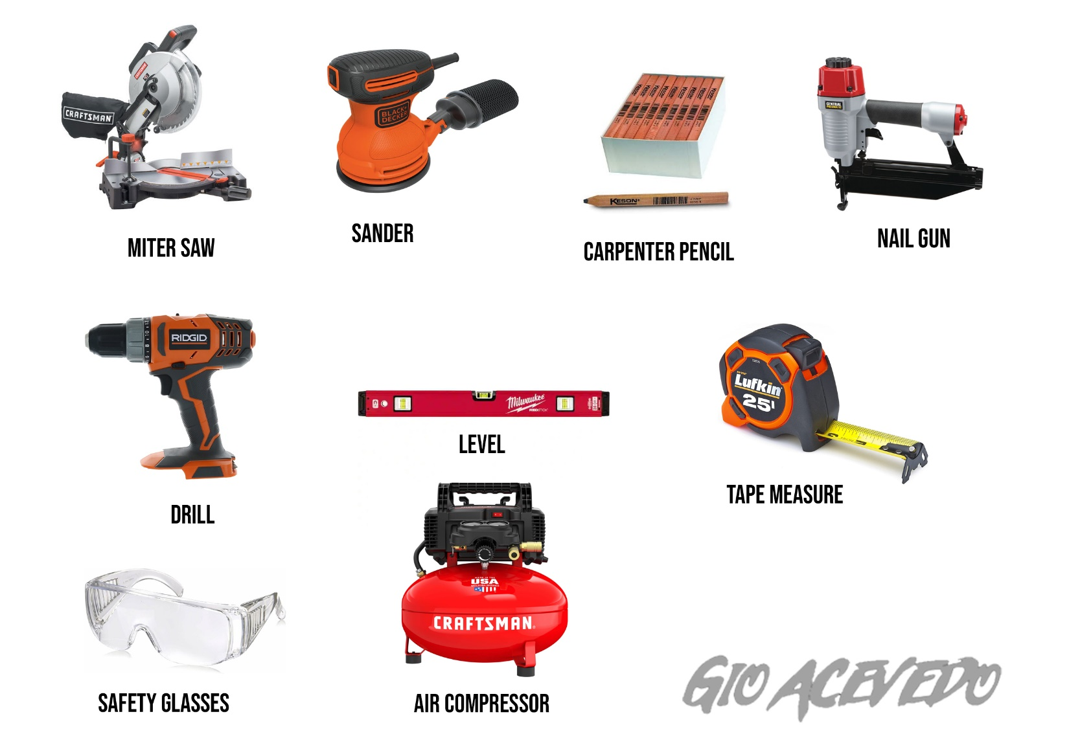

Make sure to measure twice so that you only have to cut once. Also, remember to wear eye protection. Once I had all my cuts ready I moved on to 4x4 post placement.
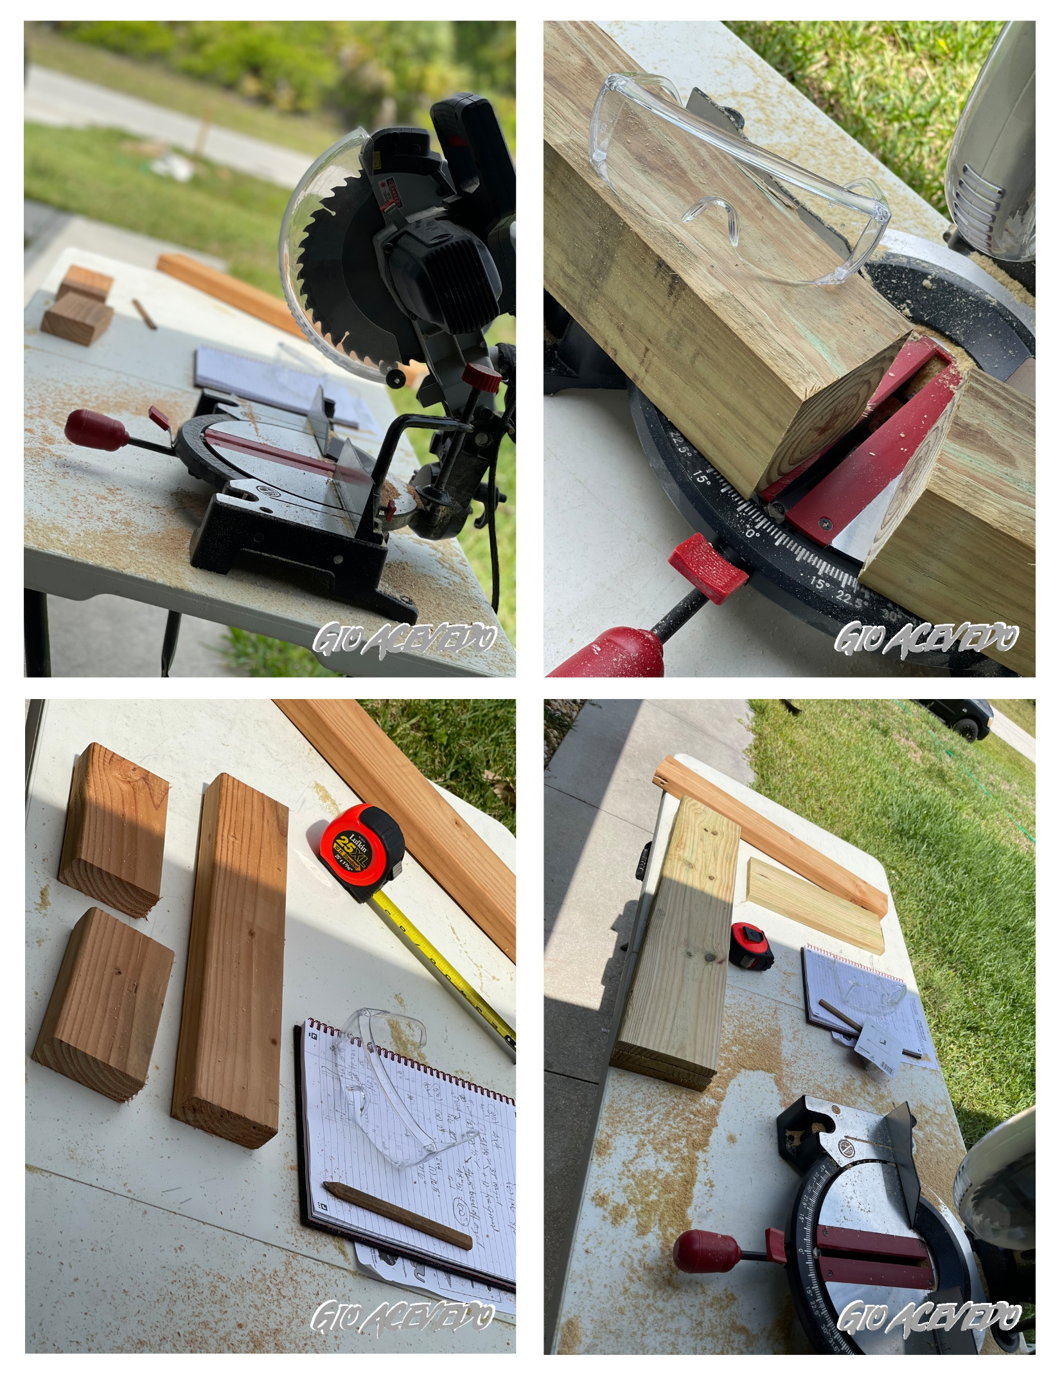
I had the original post from my old mailbox already in place, It stood around 37 ½” high. I used this as my starting point for my front post. I measured around 16 ½” from my front post to where my back posts would be factoring in my mailbox dimensions.
Here is the beginning of the hole for the other two posts. I opted to go with a concrete pour instead of a concrete pad. I dug the hole around 12 inches deep. You can opt to go deeper but keep in mind the cut measurements will change.
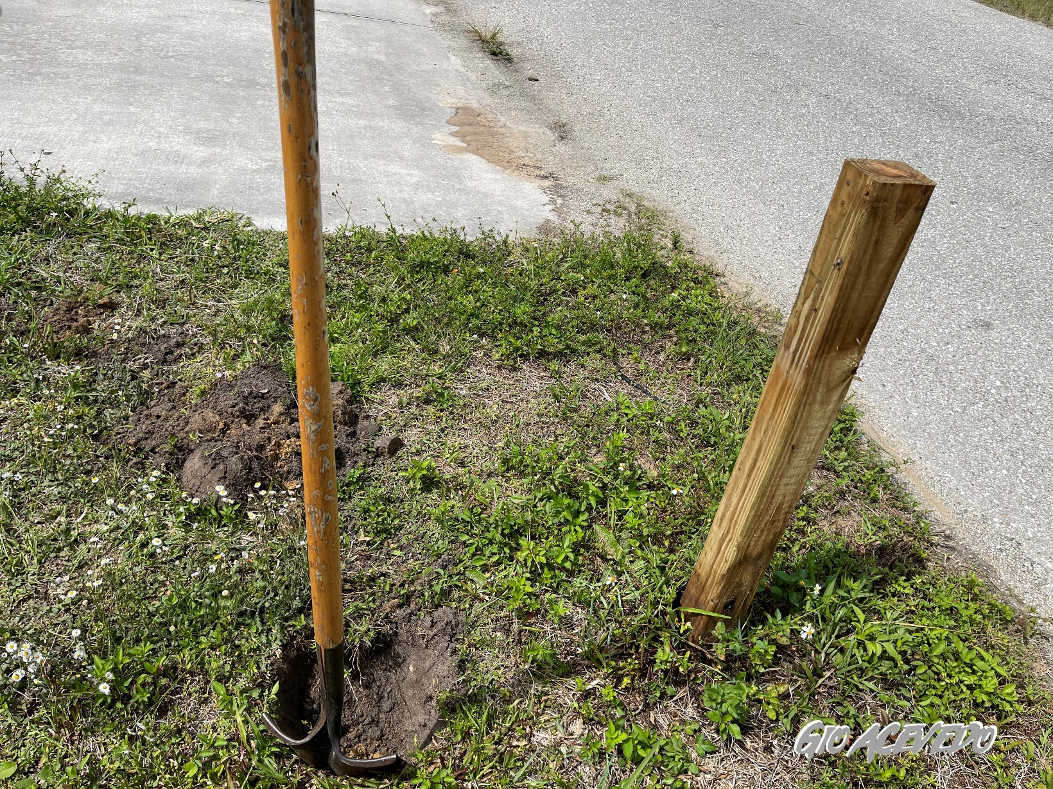

Then I added a 6” piece of 2x4 2 inches from the top to support the 16 ½” 2x4 that will run across for the mailbox support. I added a 6” piece of 2x4 to the back 4x4 post and placed it 12” deep into the hole. The 16 ½” piece of 2x4 was screwed on to the 6” supports using 3” screws. Always double check with a level to make sure everything is well balanced.
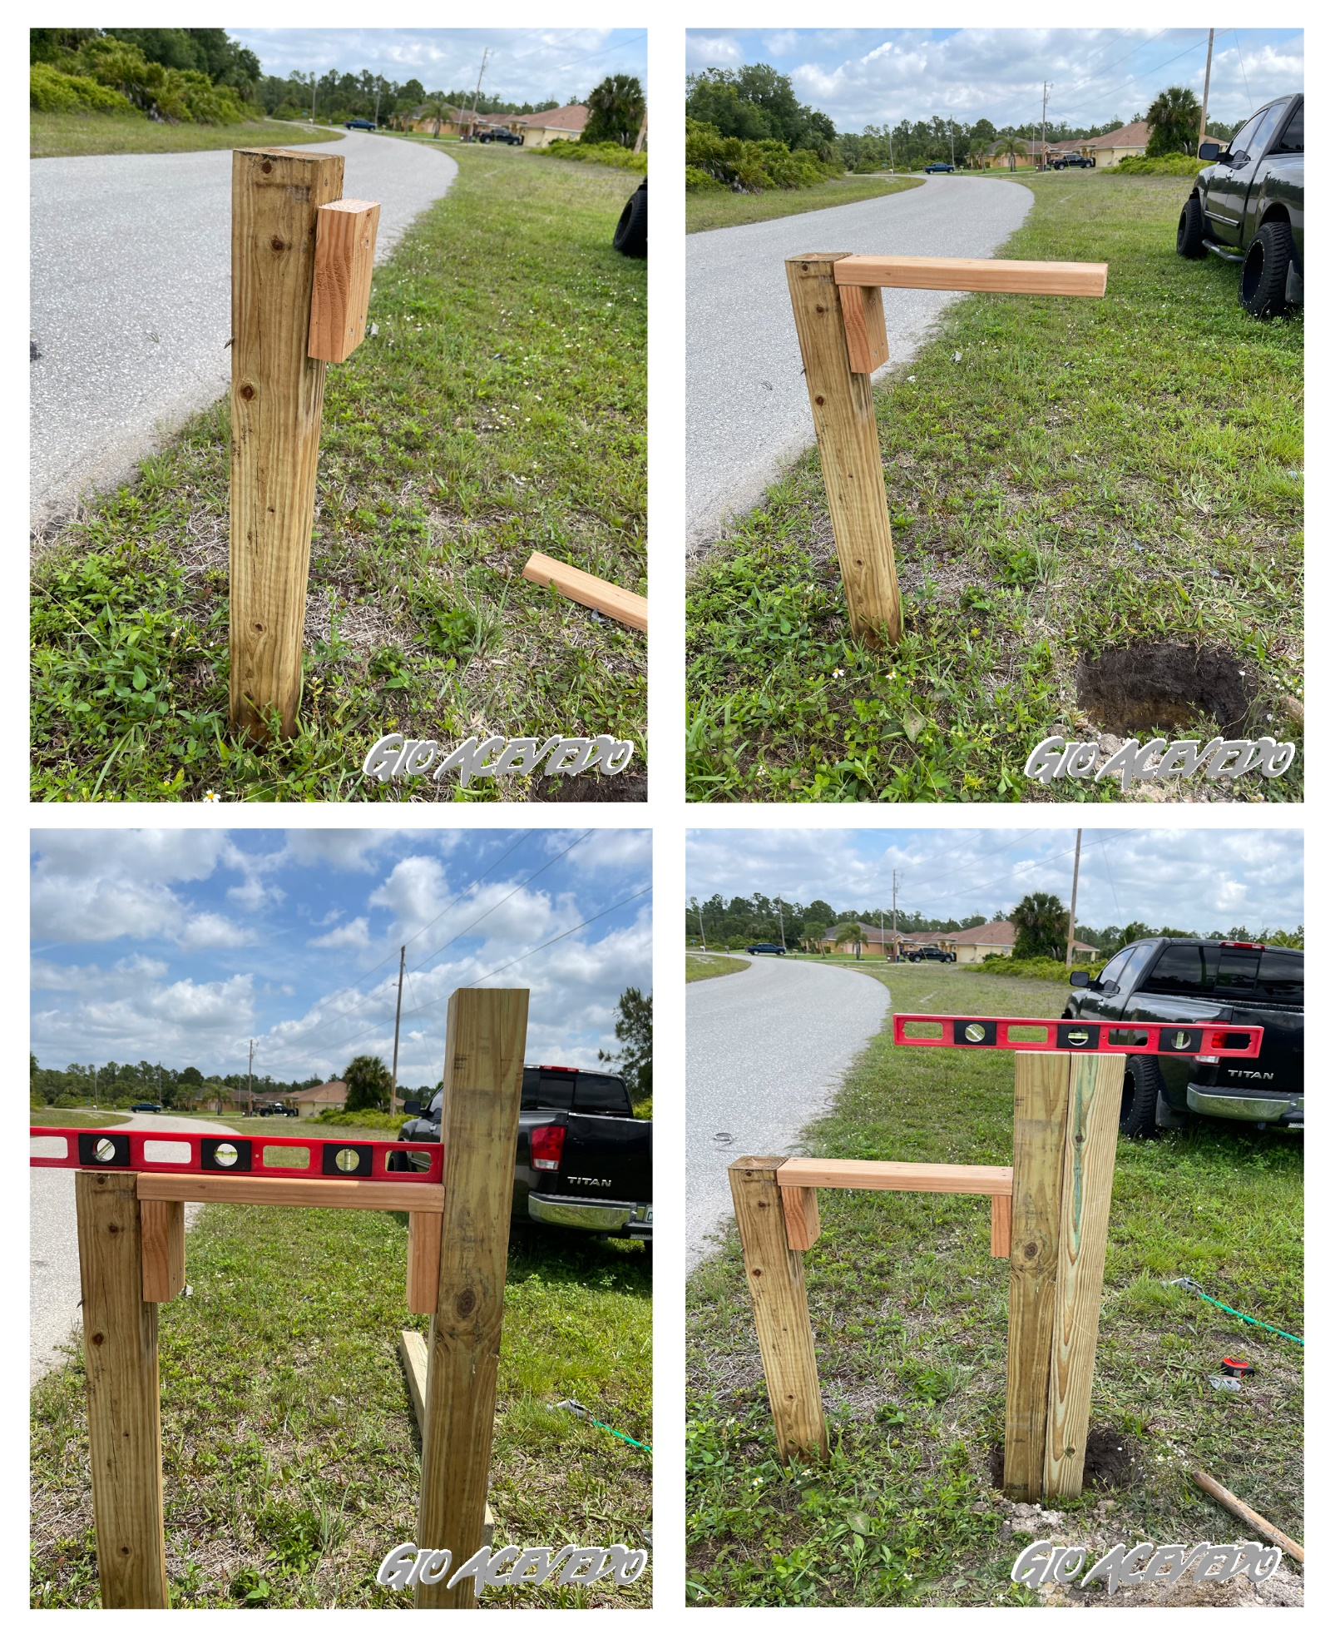
At this point I added the secondary rear post and 12” deep and made sure everything was leveled. I dumped half the bag of quick setting concrete into the hole making sure to get an even fill all around the diameter of your posts. Afterwards wet the concrete with water until it is all well saturated. I used a shovel to mix it around to make sure it had even mixture. I then filled the hole with the dirt that was originally taken out to plant the posts.
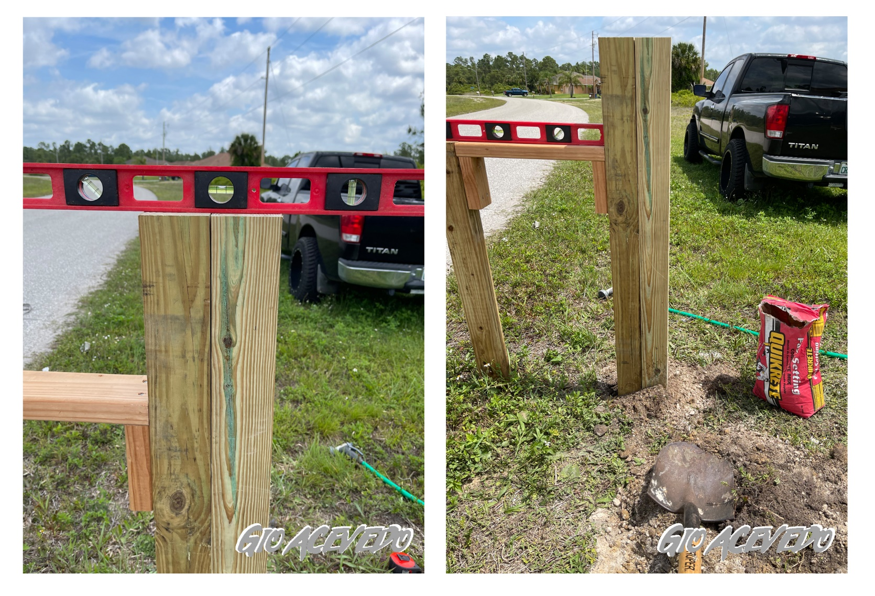
I then waited 30-40 minutes for the concrete to set before continuing. While I was waiting I went ahead and sanded down all the 1x6 boards that will be nailed to the side of the mailbox base. You want to make sure you sand every board down smooth. In some cases I had to sand down the marking on the wood until the grain underneath came out.
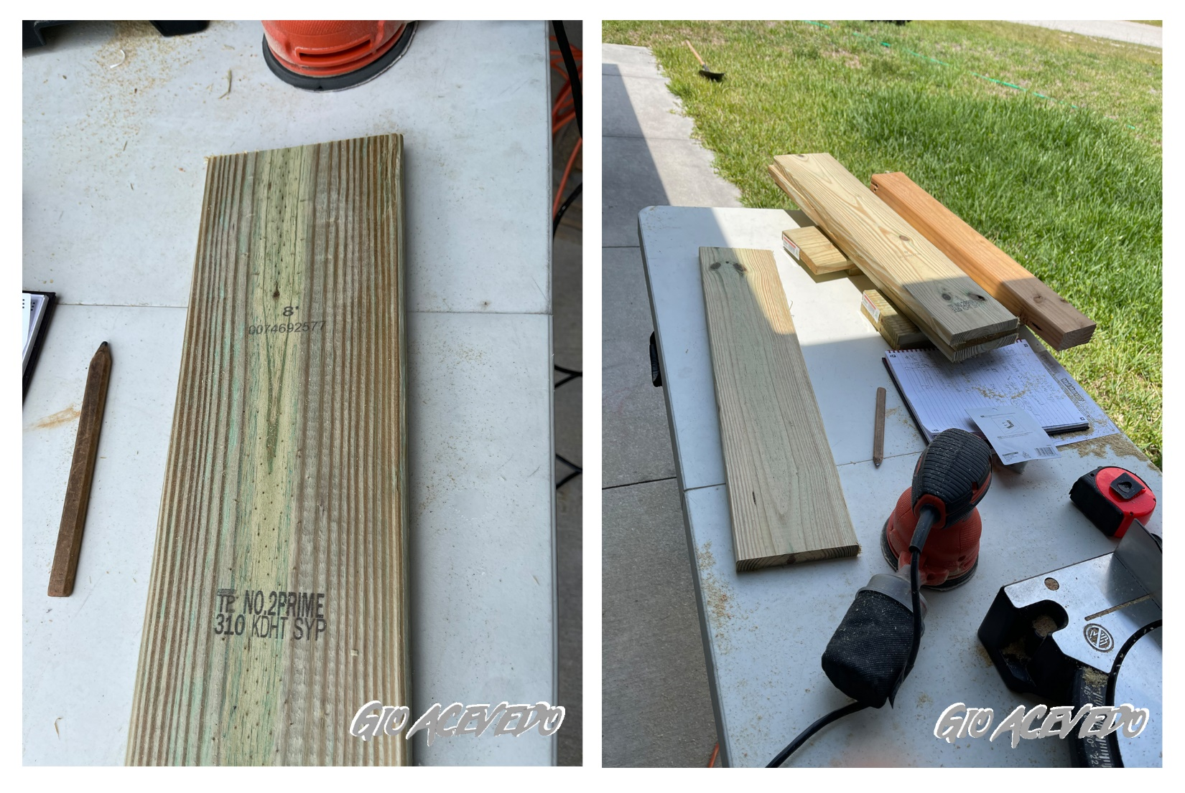

Once the concrete had set I placed the mailbox on top of the middle support and opened the mail door until it was resting freely while opened. I measured that the mailbox was centered and marked the 4 drill holes. I added the secondary 13” 2x4 underneath for more support.
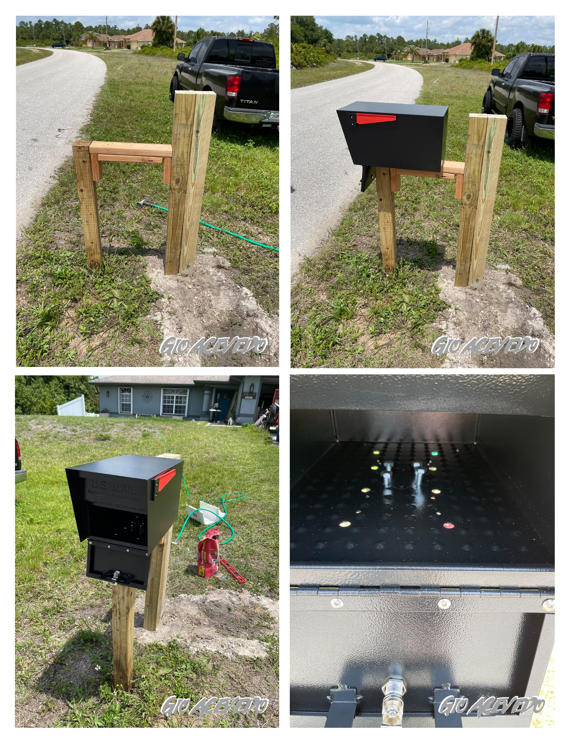
Next, I added the 27” wood slats starting with the bottom of the mailbox until the bottom using the brad nails on an air compressor. Then I added the two 11 ½” 1x6 boards that went behind the mailbox. Lastly, I added the 47" with a 45 degree angle (back), the 11” with a 45 degree angle (top), and the 36" board (front). (These are not pictured).
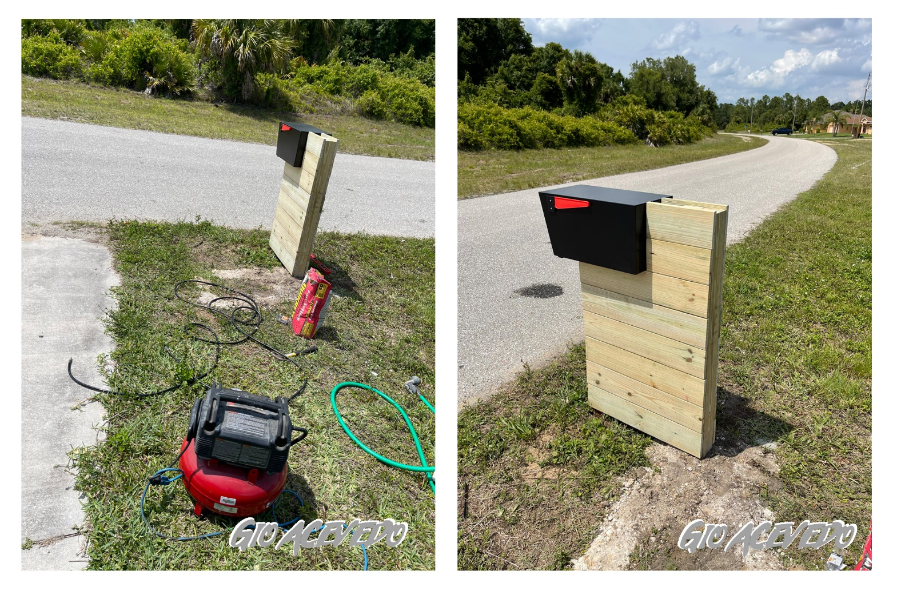
Next, use the stain that you purchased. In my case, I used Rustoleum Cognac followed by fast drying polyurethane once the stain is dried. Pictured below is after 1 coat, not dried.
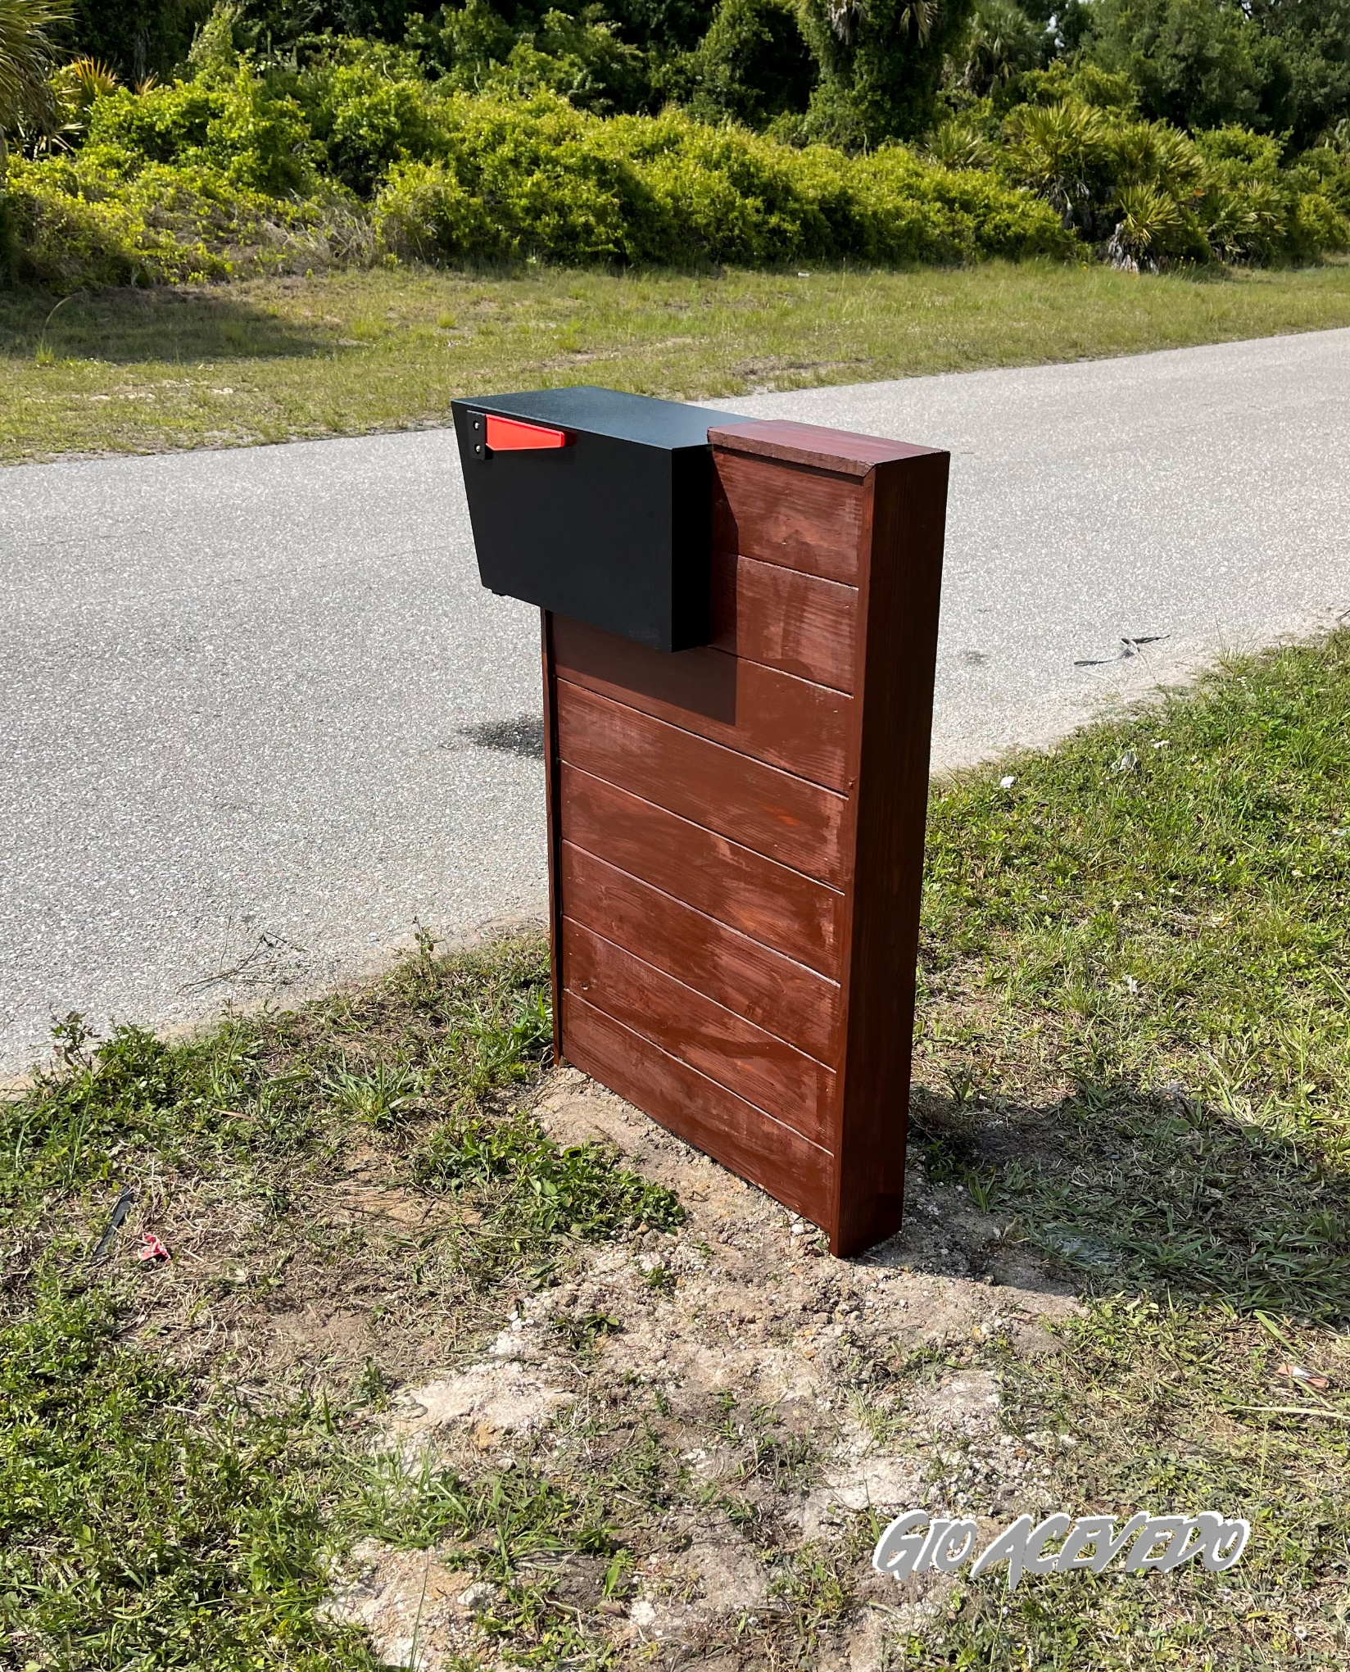
I decided to add 5 in. Elevated Satin Nickel Plated Numbers by Everbilt. Just follow the directions on whichever product you buy to finish up the build. For the Everbilt numbers I drilled holes on the number patterns and inserted the anchors. I then added the spacers and the screw ins to the numbers and used a rubber mallet to finish installing.
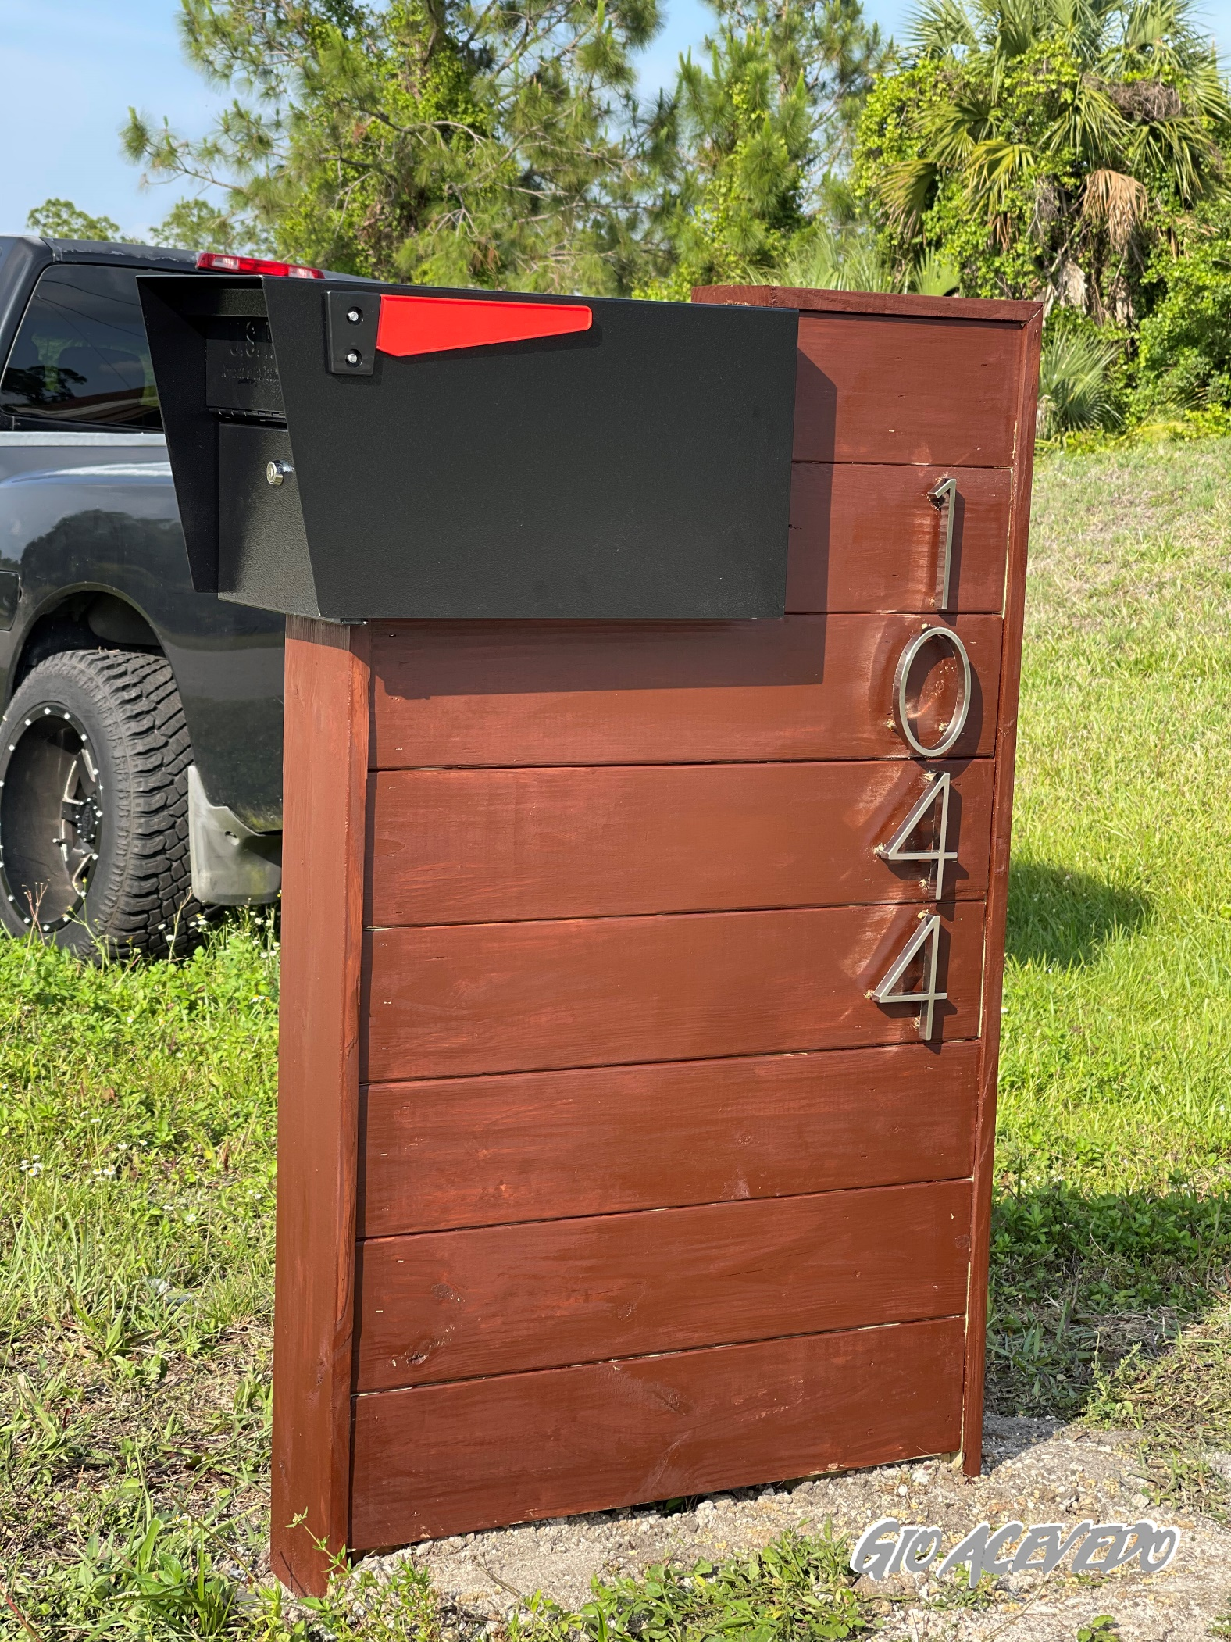

Dimension Reference

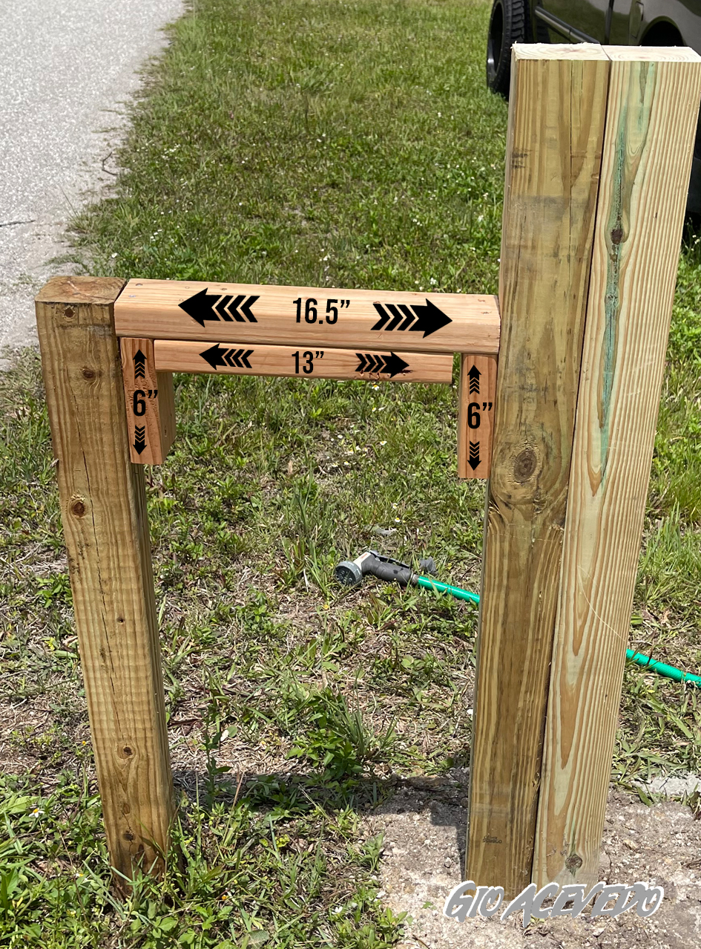

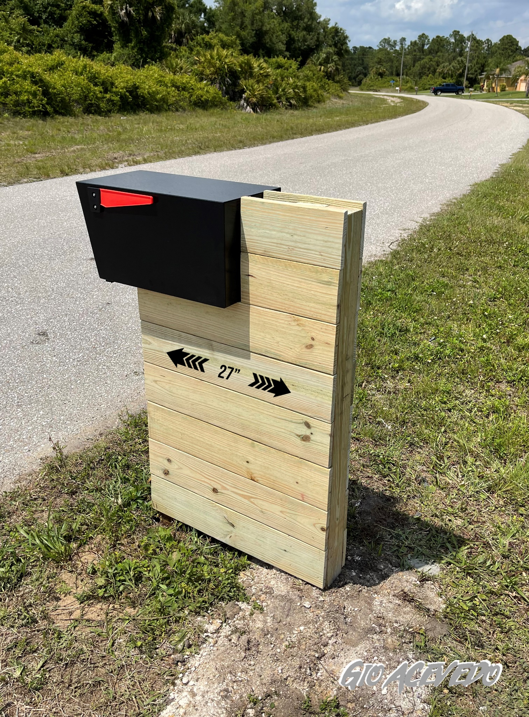

Finishing Instructions

Finish Used
Rustoleum Cognac Finish
Minwax Fast Drying Polyurethane

